ASSIGNEMNT – 3

Overview of the Dataset :

Four tables are included in the dataset containing the basic information about the users, their daily completion percentages of lessons, the lesson details, and list of rewards.

users_basic_details:

user_id: unique id of the user [string]

batch_week: week of the batch, for which the user is enrolled [date]

challenge_start_date: date at which the challenge started [date]

day_wise_user_learning_activity:

datetime: date and time of learning of the user [datetime]

user_id: unique id of the user [string]

lesson_id: unique id of the lesson [string]

day_completion_percentage: percent of the lesson completed by the user on a particular day (out of 100%) [float]

The completion percentage is calculated by the formula = learned duration of a lesson on a day/total duration of the lesson * 100

overall_completion_percentage: overall completion percentage of the lesson till that datetime by the user (out of 100%) [float]

Example: If a user, who started a lesson on Jan 1, ’22 completes the lesson by learning it in parts (20%, 43%, 37% each day) on 3 different days (Jan 1, Jan 3, Jan 4), then

Jan 1, ‘22 ; day_completion_percentage - 20%, overall_completion_percentage - 20%

Jan 3, ‘22 ; day_completion_percentage - 43%, overall_completion_percentage - 63%

Jan 4, ‘22 ;day_completion_percentage - 37%, overall_completion_percentage - 100%

Note: The lesson will be considered as completed on the day when the overall completion percentage is 100, i.e., on Jan 4, ‘22

lesson_details:

lesson_id: unique id of the lessons in the learning platform [string]

lesson_duration_in_mins: the duration of each lesson in minutes [integer]

challenge_rewards:

total_weekly_goals_achieved: no. of weekly goals achieved [integer]

reward: reward to be awarded based on the weekly goals achieved[string]

<https://docs.google.com/spreadsheets/d/1CXd3-QE5xz4KU5_1ONLWrIikOucf1EmzM-MTD92VY_I/edit?gid=2137630236#gid=2137630236>

1. Retrieve the total number of lessons and the average duration of lessons from the lesson_details table.

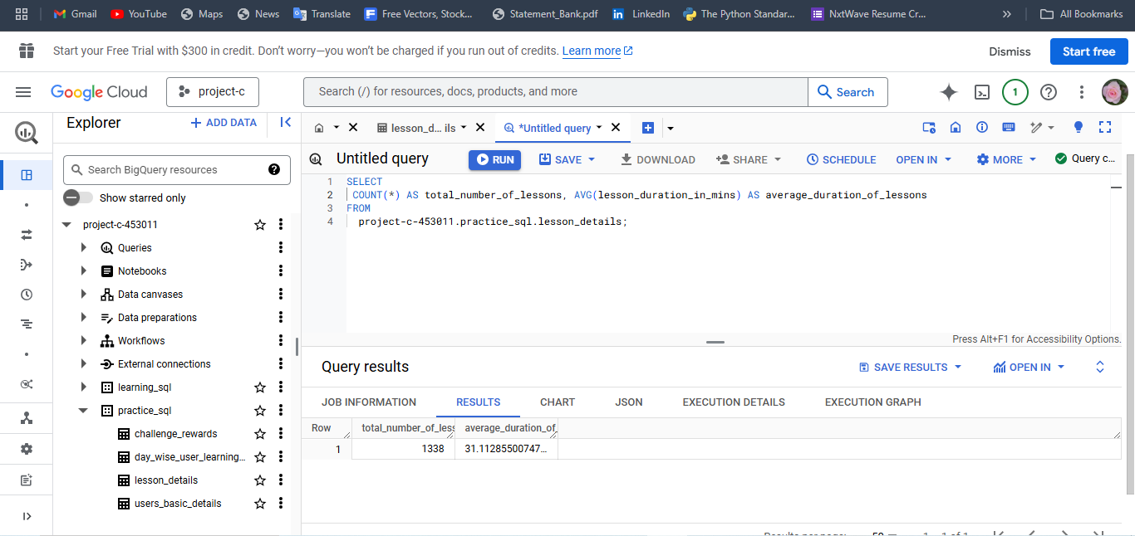

1. List all users who have completed at least 1 lesson. Display their user_id and the total number of lessons they have completed.

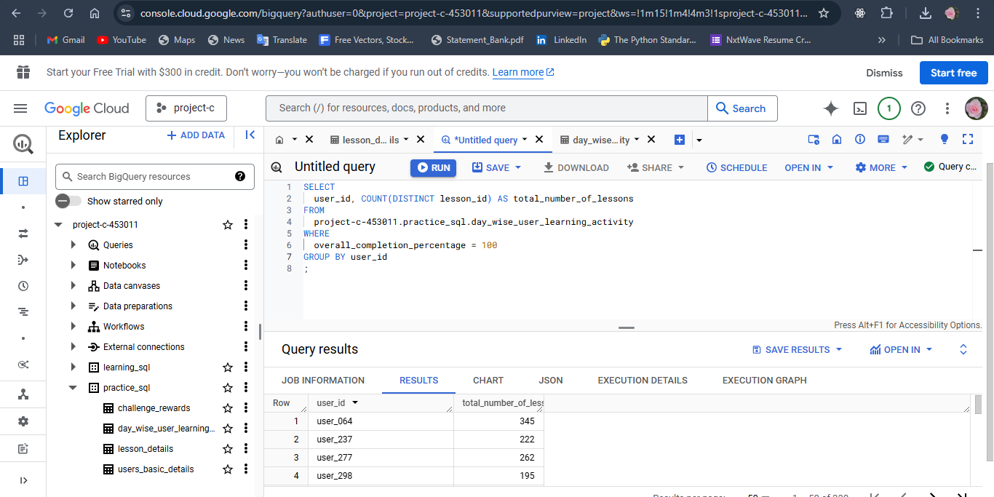

1. Find the user_id, challenge_start_date of users who started their challenge on or after January 1, 2023 and completed at least one lesson after starting the challenge

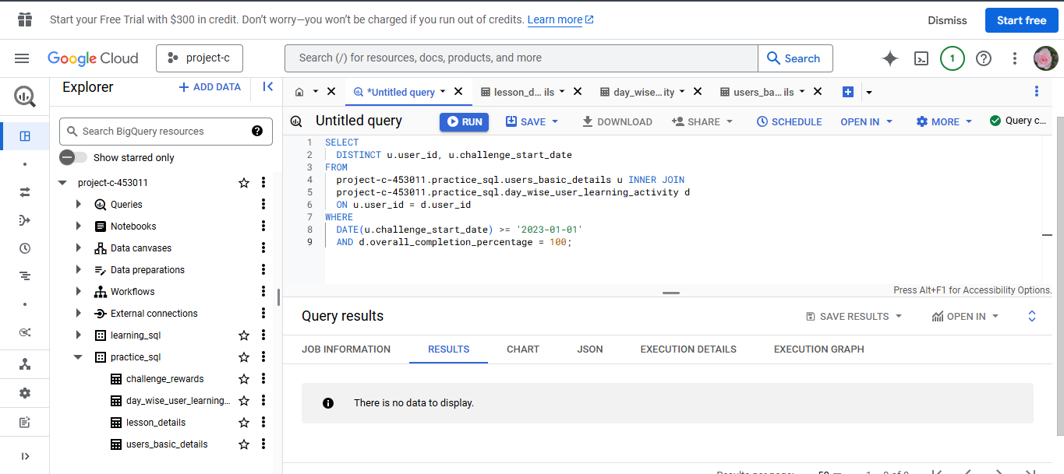

1. Create a CTE to find the total lessons completed by each user. Use this CTE to retrieve users who have completed more than 4 lessons.

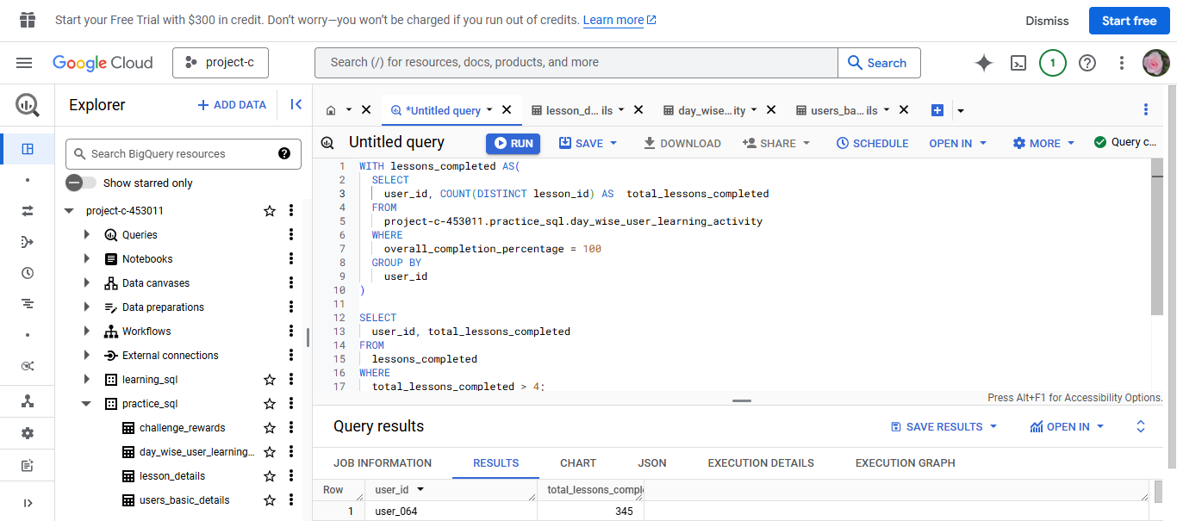

1. Create a view CompletedLessons that lists the user_id and lesson_id for all lessons that have been completed by the users. Then, retrieve the data from this view.

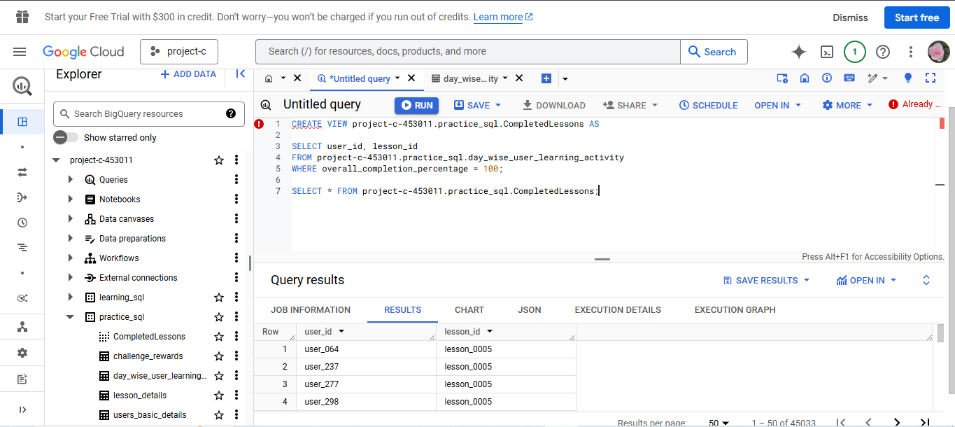

1. Find the user_id of users who have completed more than 5 lessons and use a function to display a message saying "Completed lessons count: X" as completed_lessons_count column where X is the count of completed lessons.

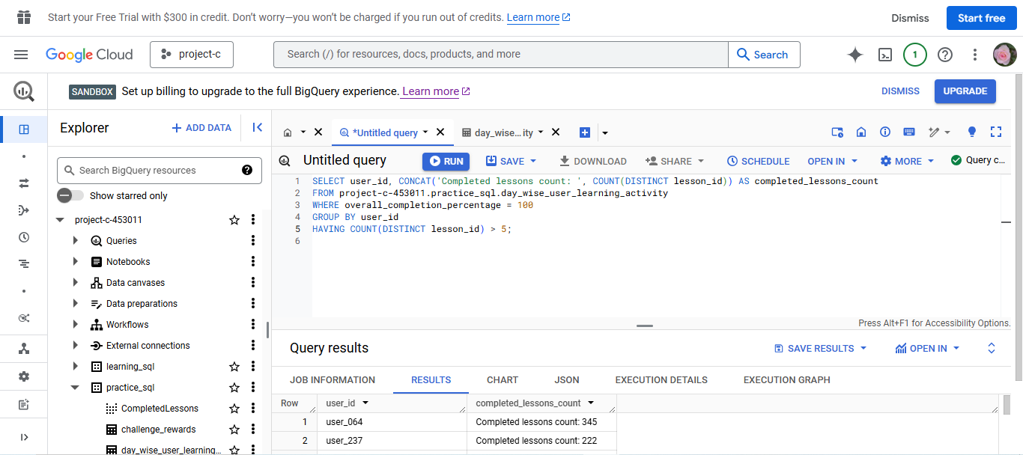

1. Retrieve the user_id and total duration of lessons which were completed by each user. If the user has not completed any lesson yet, then show the string “Yet to complete lesson” using a string function (NOT CASE)

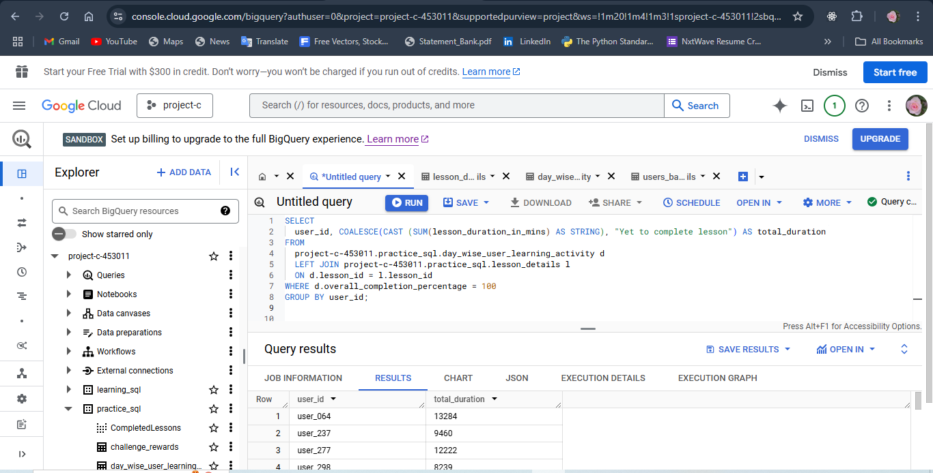

1. Create a CTE that calculates the number of lessons completed by users within the last 30 days. Retrieve the user_id and lesson count from this CTE.

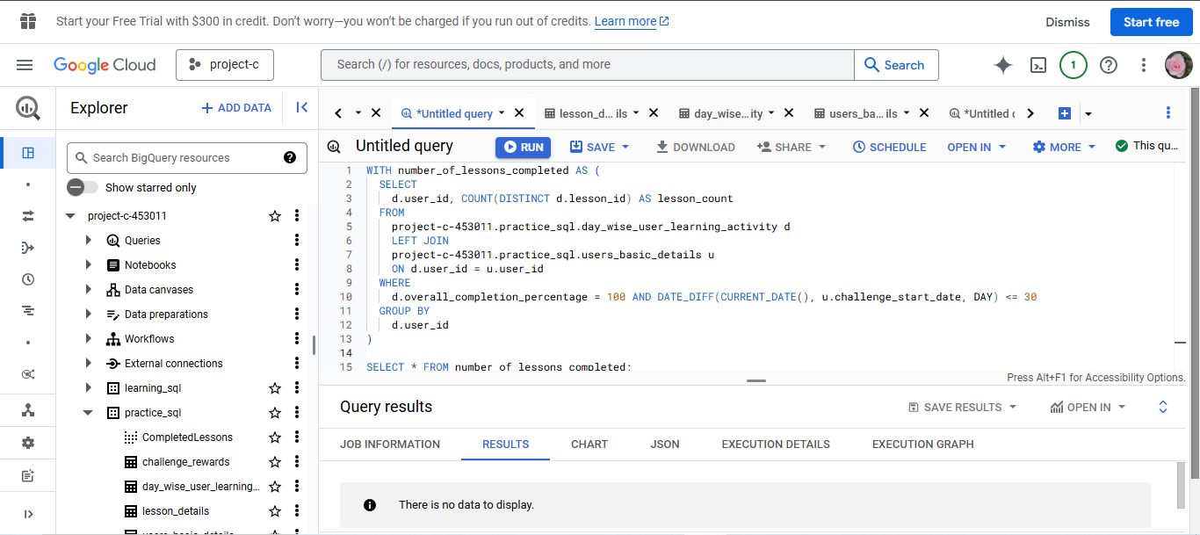

1. Categorize users based on whether they started their challenge within the last 30 days. Retrieve user_id and category. If the user has started within the last 30 days, then tag them as “Recent User”. If not, tag the user as “Not a Recent User”

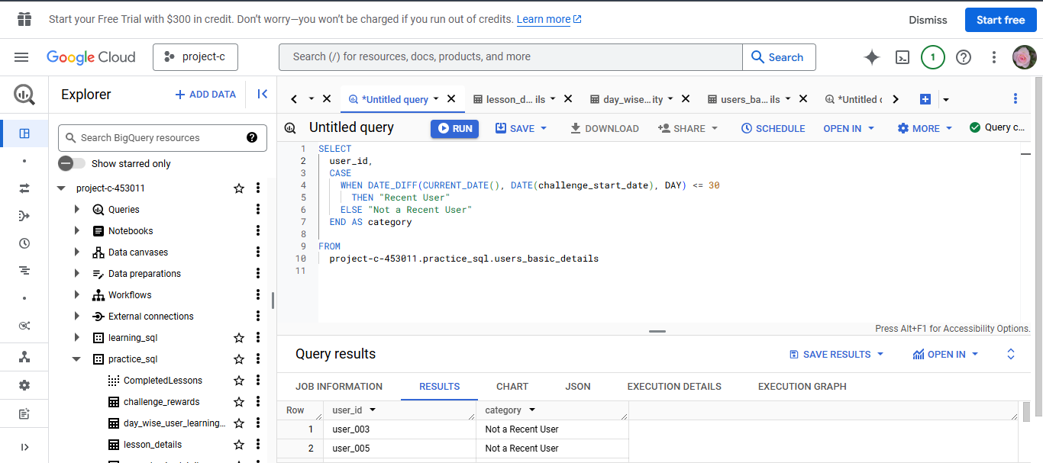

1. Get the users whose duration spent is above the average duration spent of all the users using a subquery.

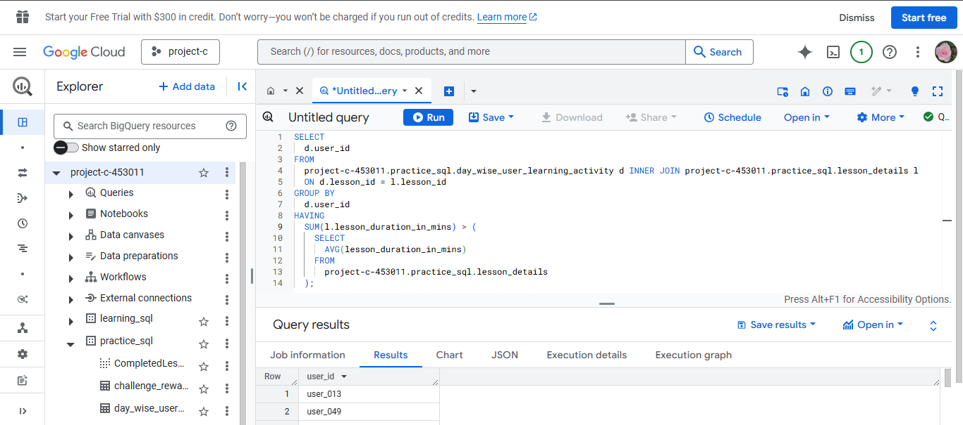

1. Display users who have started challenge in the last 3 months or those who have completed 10 lessons till now.

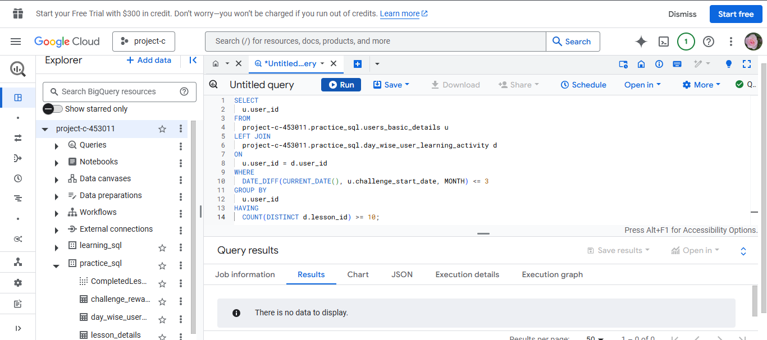

1. Categorize users based on the number of lessons that they have completed.

If the user has completed >3 lessons - “basic”

> 7 - “Neutral”

> 10 - “Good”

Give correct logic in the required order to categorize users properly.

